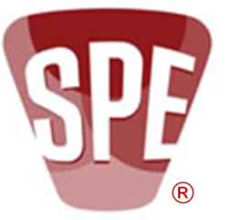

Society of Plastics Engineers Detroit Section Board of Directors Meeting Minutes
November 24, 2014 Board Meeting
Meeting Location Call-In Information
American Chemistry Council U.S.: 626-677-3000
1800 Crooks Road Pass Code: 8045975
Troy, MI 48084

Attendees – Marc Bahm, Dawn Cooper, Pete Grelle, Wayne Hertlein, Norm Kakarala, Jim Keeler, Gary Kogowski, Christopher Lafayette, Sandra McClelland, Adrian Merrington, Bob Petrach, Tom Pickett, Irv Poston, Tom Powers, Ron Price, Nippani Rao, Karen Rhodes-Parker, Mark Richardson, Laura Shereda, Sassan Tarahomi, Zack, Thompson, Eve Vitale, by phone, Steve Keinath
Proxies Adrian Merrington held proxies for Todd Hogan, and Chris Surbrook. Ron Price held proxy for Bill Windschief, Sandra McClelland held proxy for Tom Miller
(Green are voting BoD members)

Meeting was called to order at 5:34 by President Sassan Tarahomi

Welcome and Introductions Sassan Tarahomi
The group went around the room and on phone with introductions

President’s Message (reserved for special item) Sassan Tarahomi
No message

Approval of Minutes- October 27, 2014 Mtg. Bob Petrach
Minutes approved with addition of Detroit Section 2014-15 Budget:2 file, which gives performance to budget for 7/1/2014 through 6/30/2015 Using Detroit Section 2014-15 Budget. Motion brought by Pete Grelle, seconded by Norm Kakarala.

Public Interest Dawn Cooper
Chevron Phillips Chemical Company donated material again this year for the third straight year. American Plastic Toys has again agreed to mold, assemble, and package. They have not started production yet do to a delay in receiving the labels. They will not handle product twice so when they receive the labels which should be today they will start production. I do not have a final number on toys since production hasn't started only an estimate of 36,000. This is the 15th year. A date has not been set to recognize the contributors yet. We hope to have the toys picked up from APT and delivered to the United Way & Lions Club the week of Dec. 15th. As soon as a date is set up for the press release/recognition I will forward the info.

Treasurer’s Report Tom Powers
“Detroit Section SPE Register Report:13, 10/27/2014 through 11/21/2014” and “Detroit Section 2014-15 Budget:2” files were reviewed. Graphic of budget performance file inserted and (as all inserted files) can be expanded by clicking and dragging larger to read.
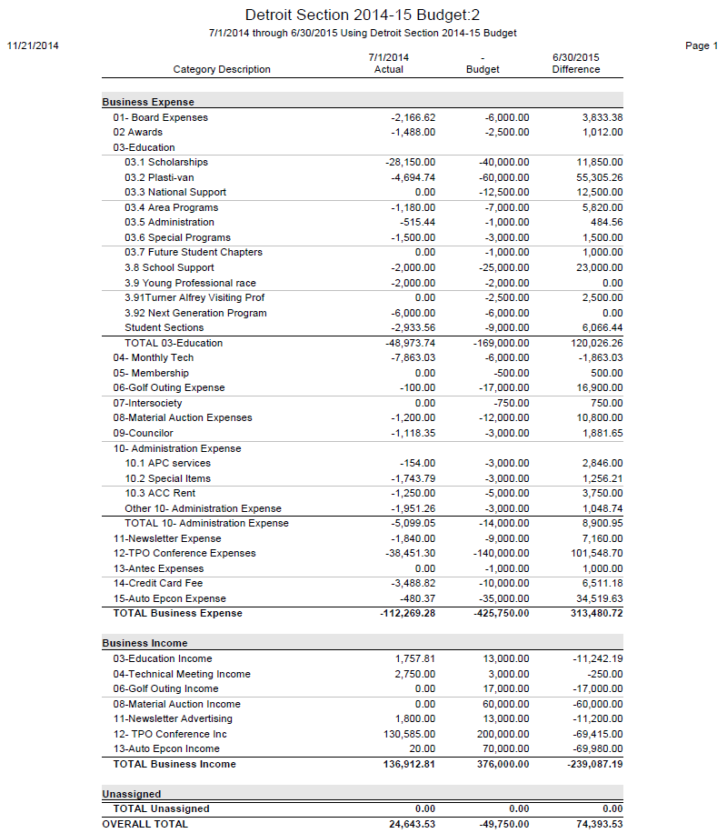

Technical Conferences
2015 TPO Conference Update Sassan Tarahomi
Presentation slides below. Not in the slides are comments by Sassan. Please accept meeting notice so anticipated attendance can be tracked. Org Chart is changing, everyone needs to complete their assignments. The contract with the Marriott has been signed for 2015. If we sign 2016 contract option before January 31, 2015 will have a 5% reduction rather than the 2% for 2015.
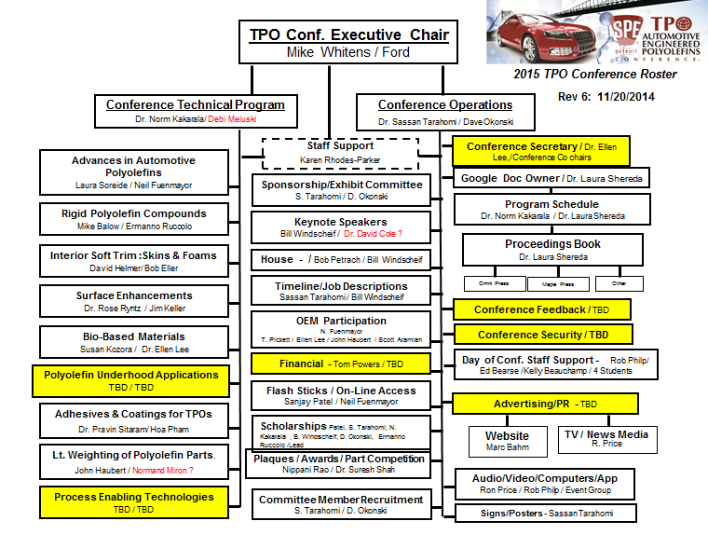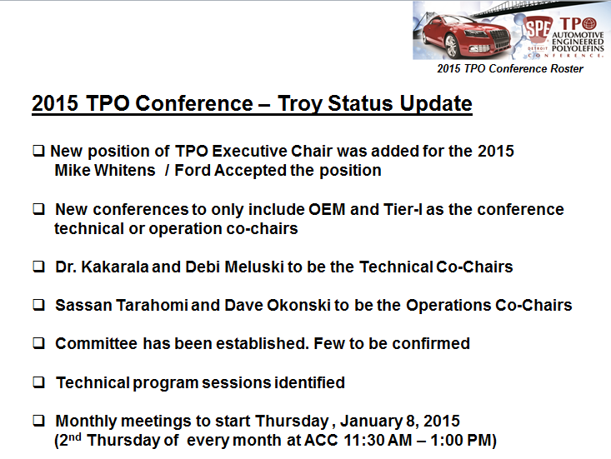
2015 Auto EPCON Update Gary Kogowski
May 5, 2015 at Marriott Detroit – Troy. Theme is Engineering Plastics in High Gear. There are 12 committee members at this time. Information is on SPE international website. http://www.4spe.org/Events/event.aspx?EventID=51213 Event registration as well as sponsorship can be done through 4SPE.org website at this time. Currently working on Keynote Speakers, looking for a total of 3 or 4, so far Rose Ryntz has confirmed as a keynote speaker. Tom Miller is leading the effort to do student presentations in addition to student moderators. Five confirmed sponsors to date and $20K collected already.

2016 TPO Conference in Shanghai Sassan Tarahomi
Sassan gave a brief rundown from results of October 5 meeting with Executive Board, Emeritus Members, Wim De Vos, Vijay Boolani, and Russ Broome. Plan is to work from the desired results (a profit of $50K to be split 50-50 with SPE International) to assure event is a financial success. It will be a 2 day event. Sandra asked if profit would have to remain in China. It does. The intent is to partner with Chinese SPE members to help them get event up and running as a continuing event. There was some discussion regarding this event reducing attendance at TPO Conference in Troy. Negative affect to Troy event was anticipated to be minimal. Main attendance is anticipated to be Chinese and due to great expense few have come here.
There was a motion by Ron Price, seconded by Pete Grelle to develop a business case for TPO China 2016. Motion passed, Ron will head efforts and report to Sassan.
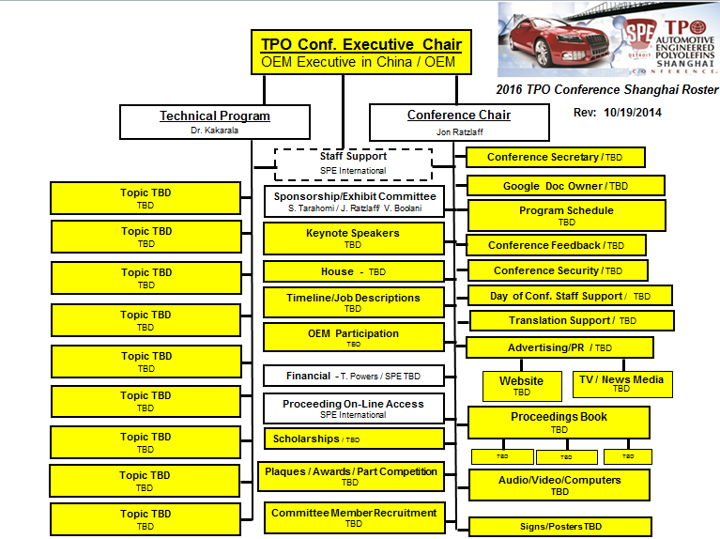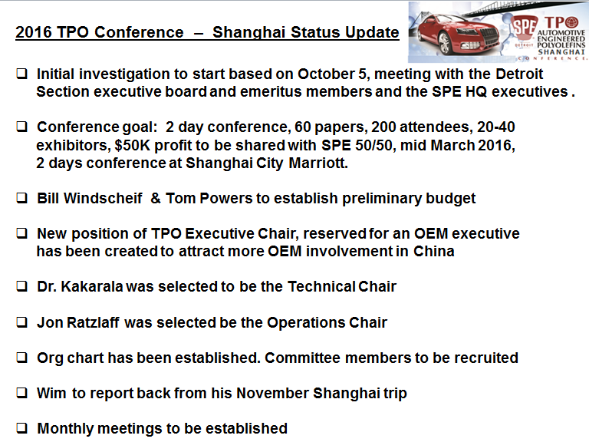

Toledo Section Review Adrian Merrington
The following file is a select collection that Sassan assembled of constructive comments, pro, con and on logistics of a possible merger of Toledo Section into Detroit Section.
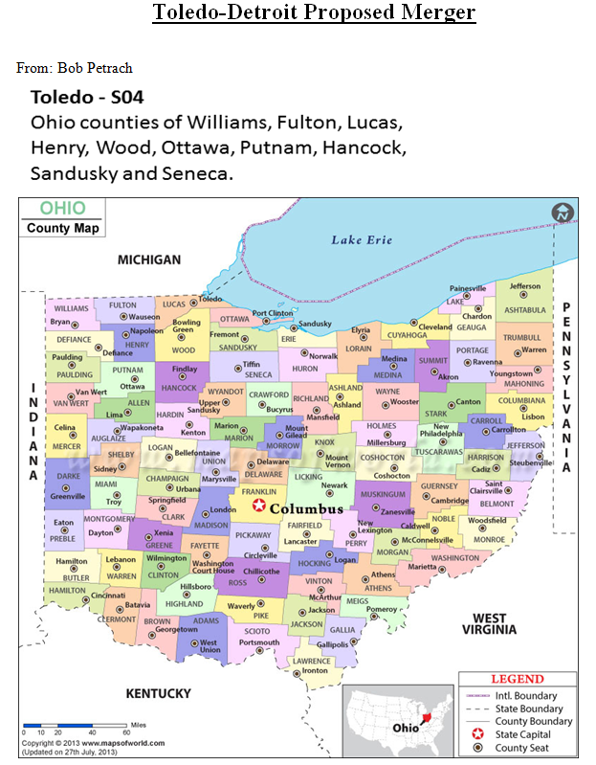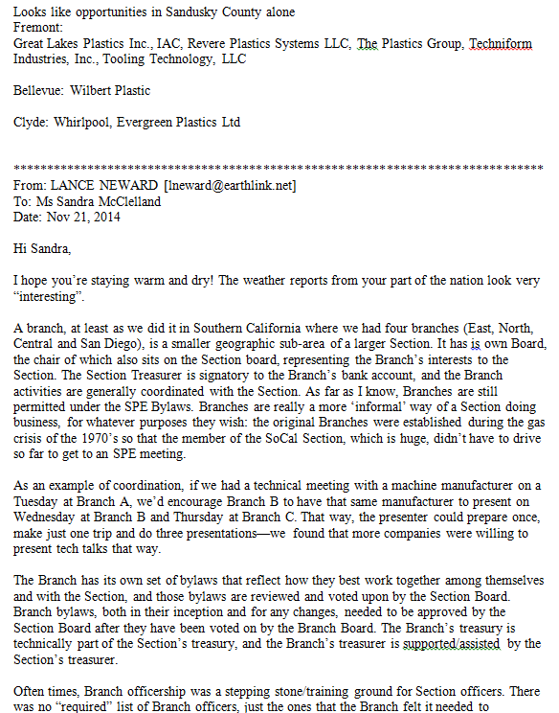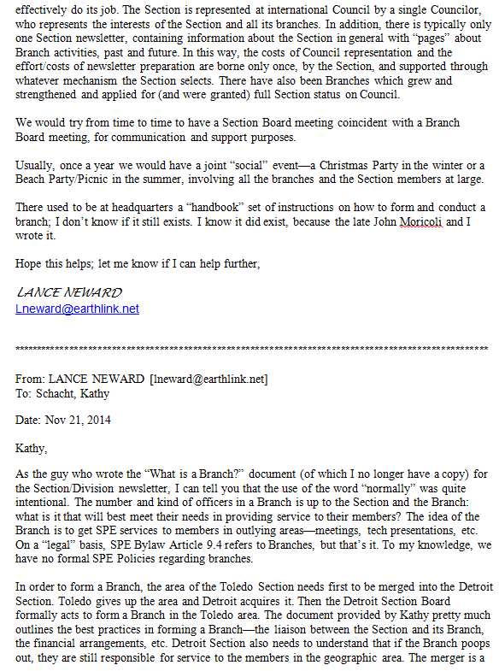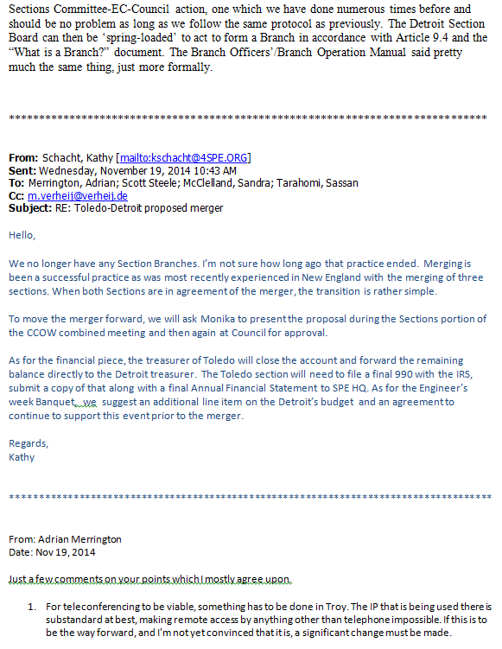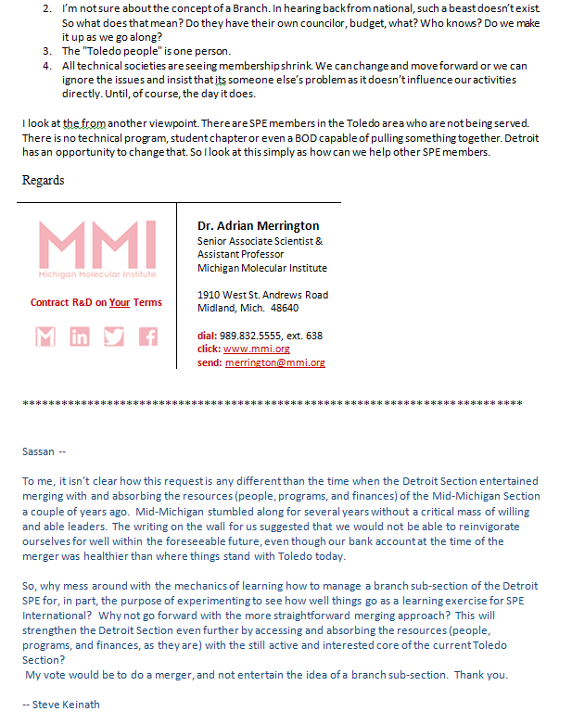
The next file is a proposal written by Scott Steele of the Toledo Section.
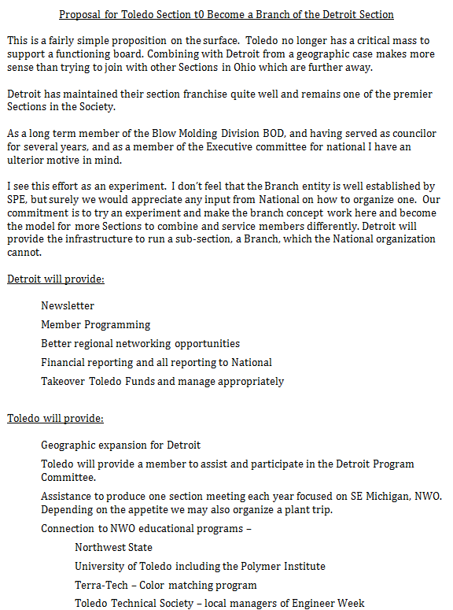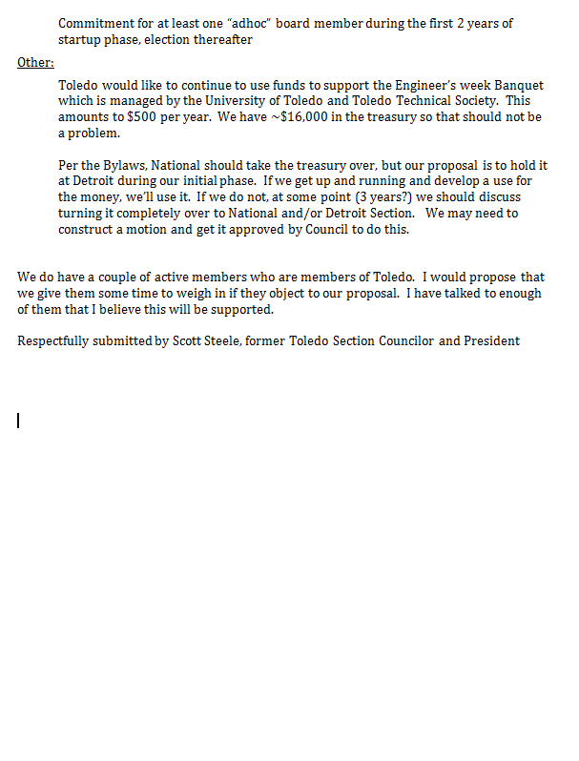
Sandra pointed out that if Toledo does not have a board of directors and officers in place by March 2015, the Toledo Section would be dissolved by the SPE Council.

There was much discussion on the need to find a way for Toledo to become viable and remain as Section 04 if at all possible or at least merge with Detroit to carry on programs established by the Toledo Section and take advantage of the opportunities for SPE given the strong plastics industry presence and opportunities in the educational community in Northwest Ohio.
It was decided that a face to face meeting with Scott Steele would be arranged to include Sassan Tarahomi, Ron Price, Norm Kakarala, Sandra McClelland with Adrian Merrington joining by phone if at all possible. Time and location to be determined.

President Elect Adrian Merrington
Chapter Liaisons Report Chapter Liaisons
No reports except a Kettering report by Eve Vitale with some comments and explanations by Mark Richardson and Chris Lafayette.
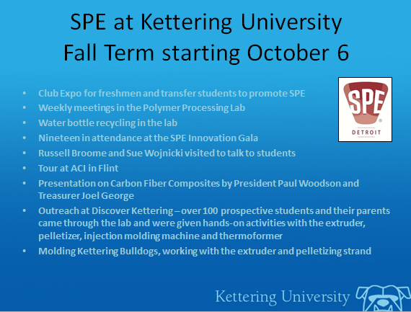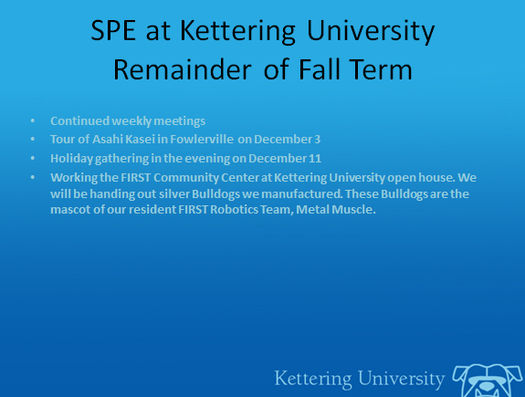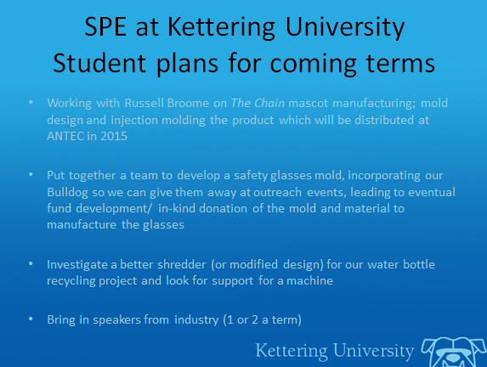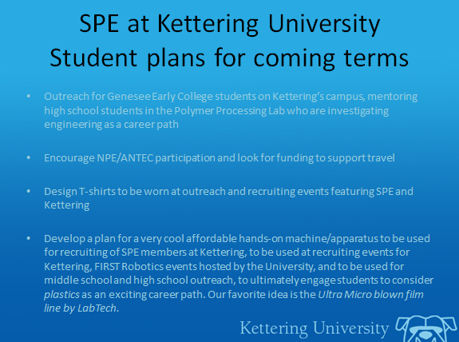

House & Programs -2014/15 Sassan Tarahomi
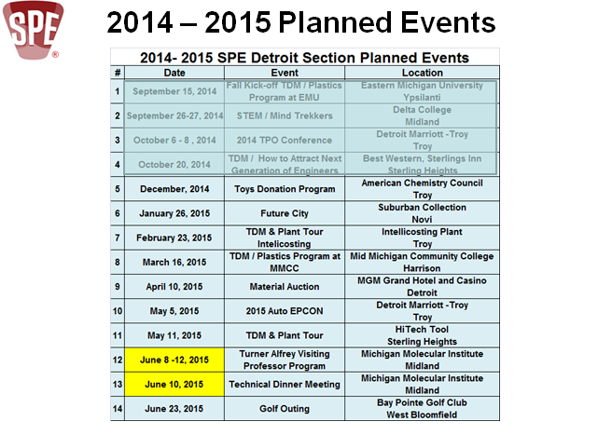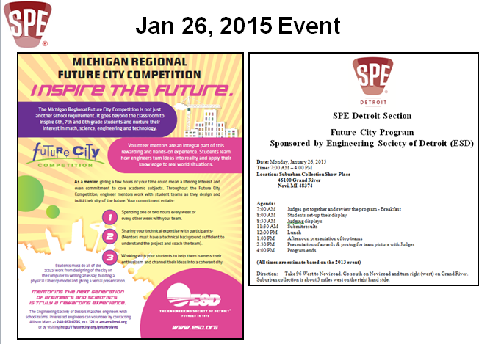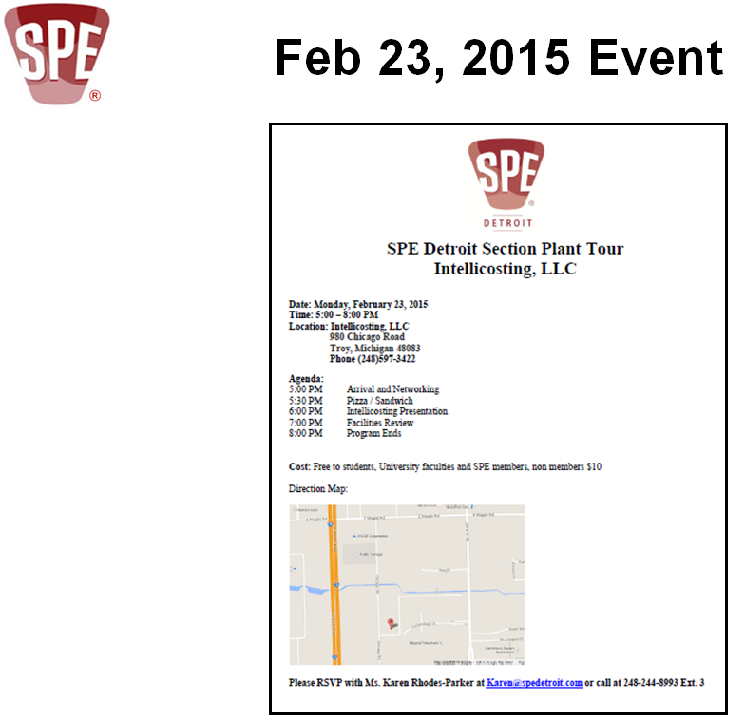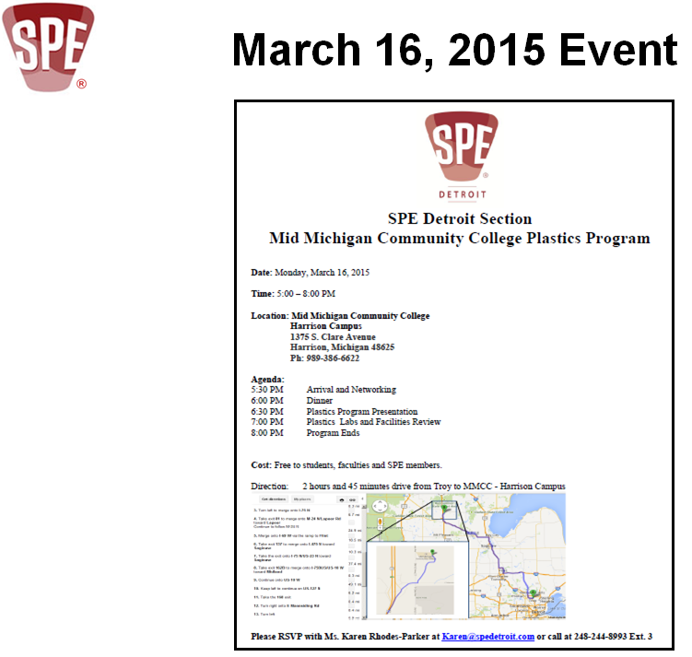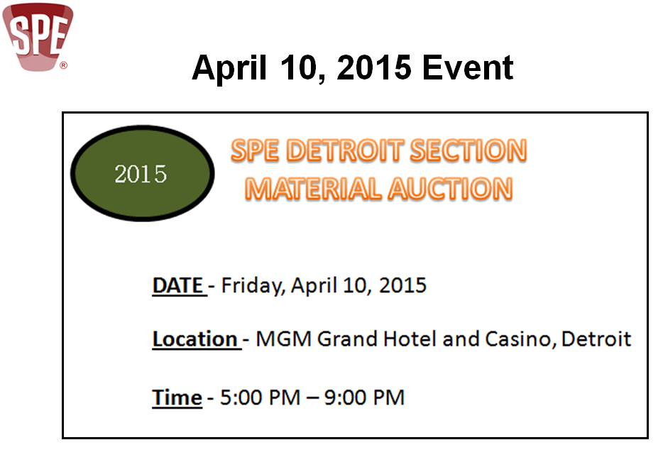
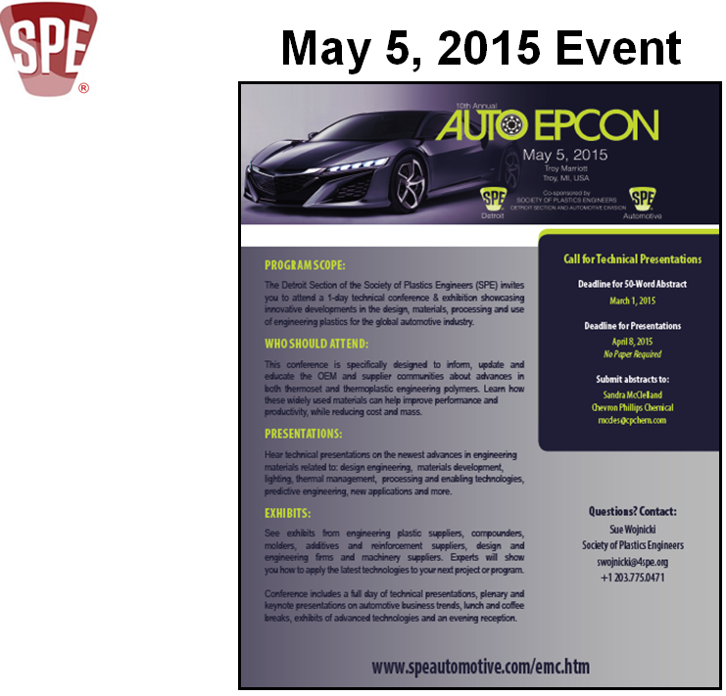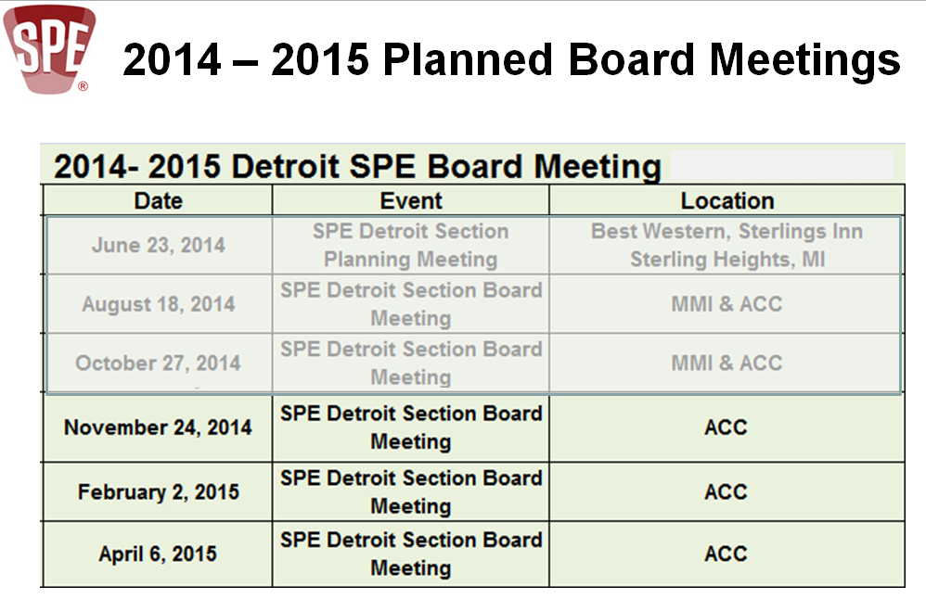

Membership Gary Lawrence
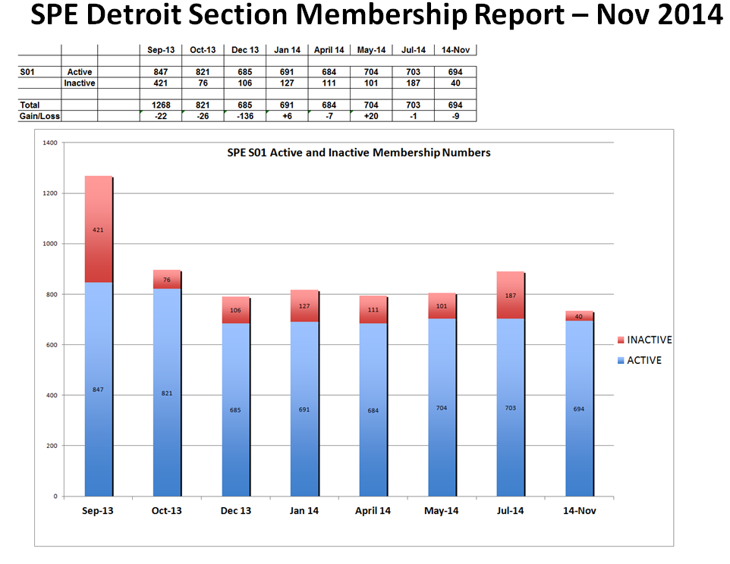

Next Generation Advisor Furkan Akdemir
Laura Shereda was asked to comment but she had missed last Next Gen meeting. She did note that they planned to participate in the scavenger hunt.

2015 Material Auction Chris Surbrook
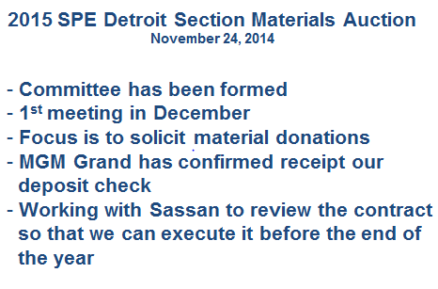

Education Sandra McClelland
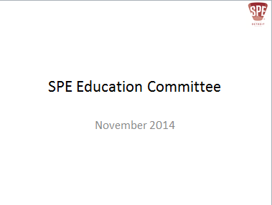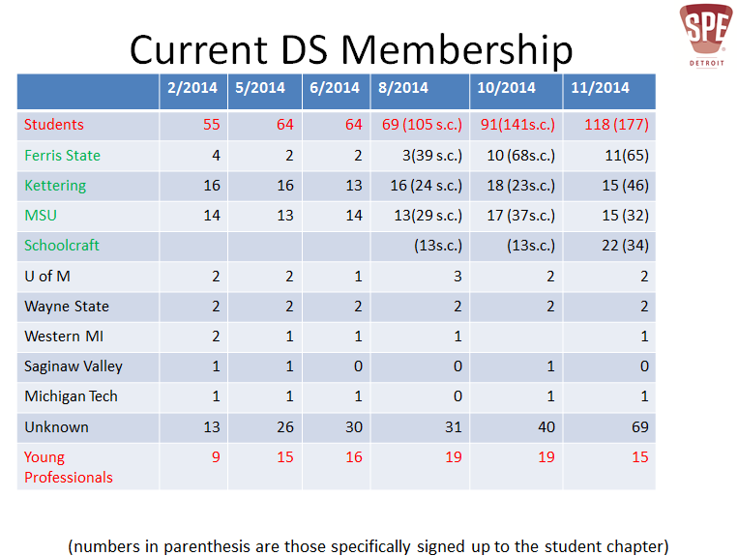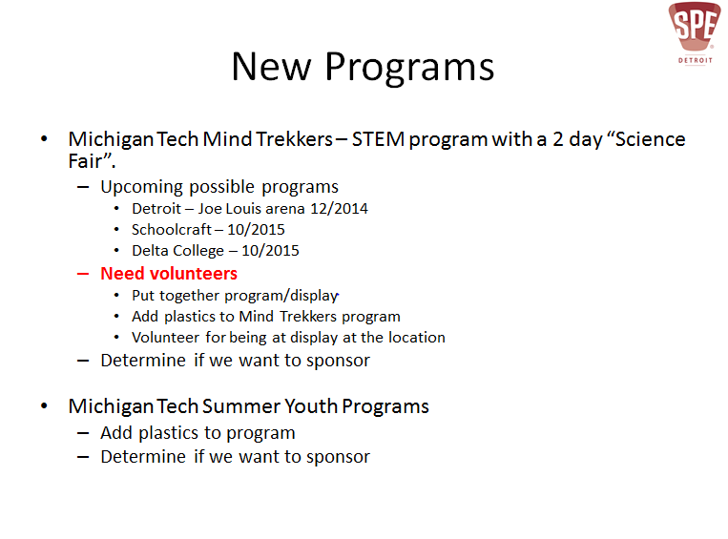

Scholarships Tom Miller
No Report

Schoolcraft Comm. College Armando Sardanopli
Sassan Reported that a new group of student officers is being formed.

MMMC & Delta College M. Wendt & T. Miller
No Report

Michigan State University Fred Dean
No Report

Ferris State University M. Wendt & T. Miller
No Report

Kettering University Mark Richardson & Eve Vitale
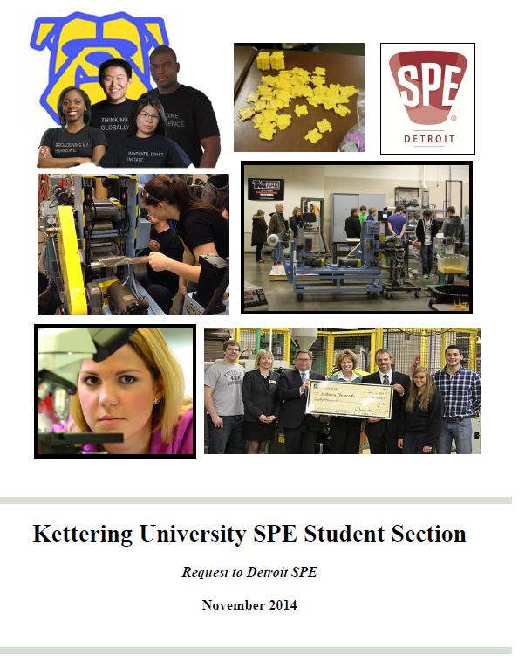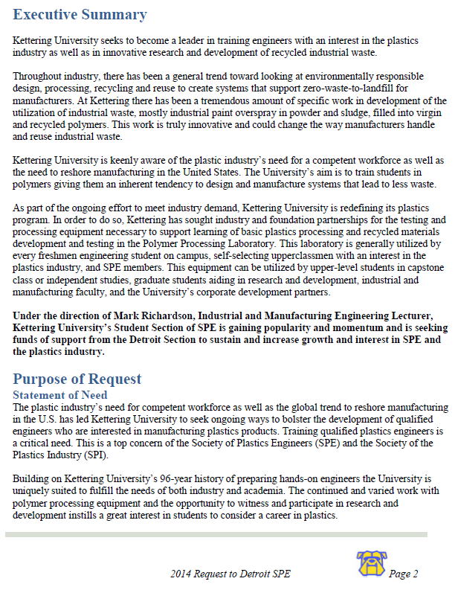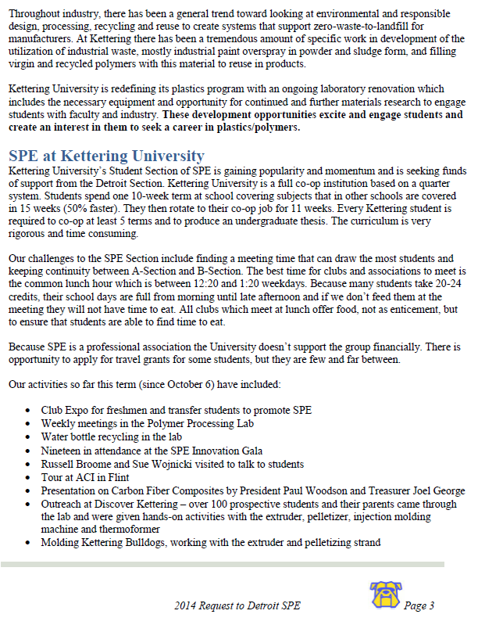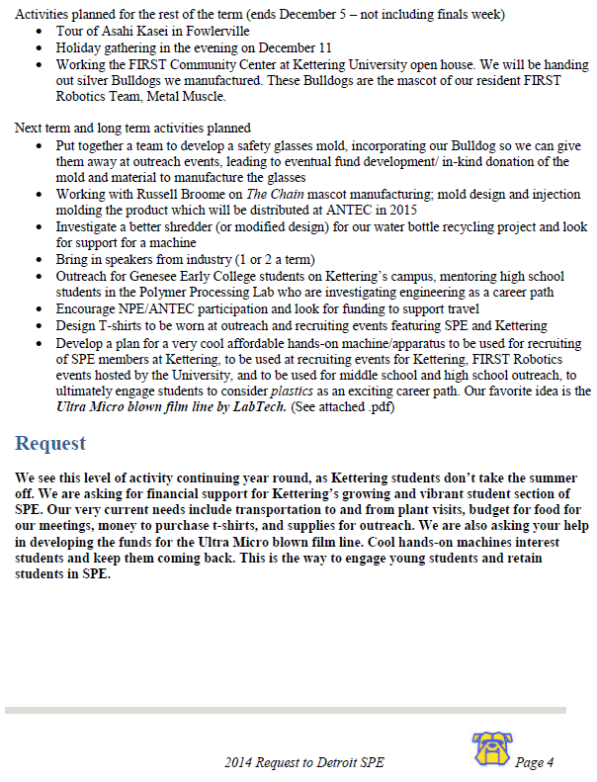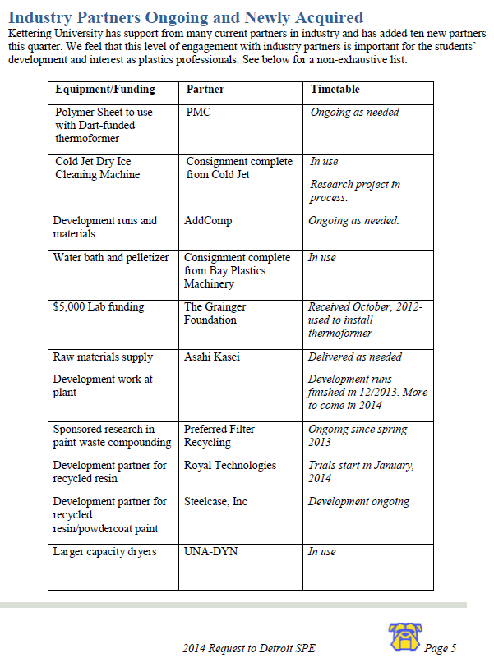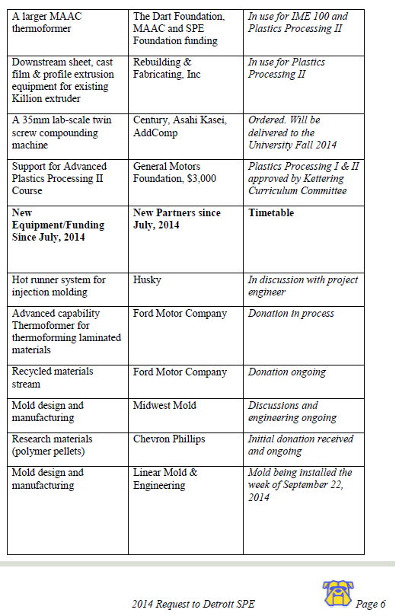
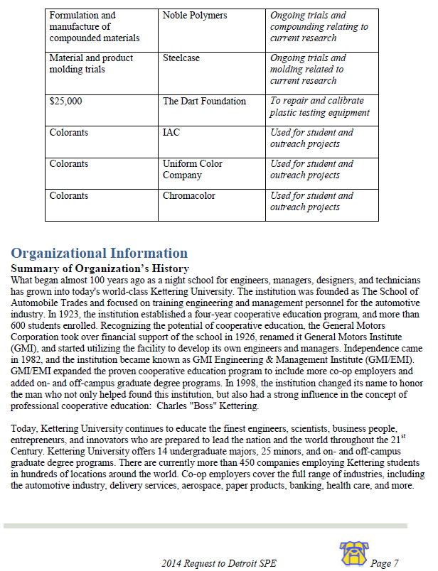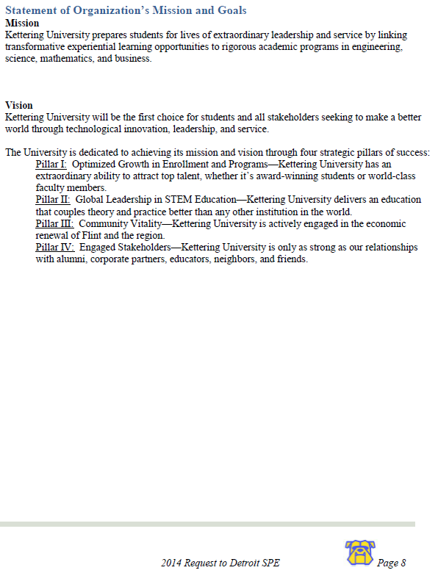
Plastivan & Essay Contest Tom Miller
Adrian instructed Tom Powers to not pay the November 6th & 7th - Jefferson Middle School visit as he was notified of the visit and Margie had been instructed to contact him prior to the visit so he could observe.
Report file follows
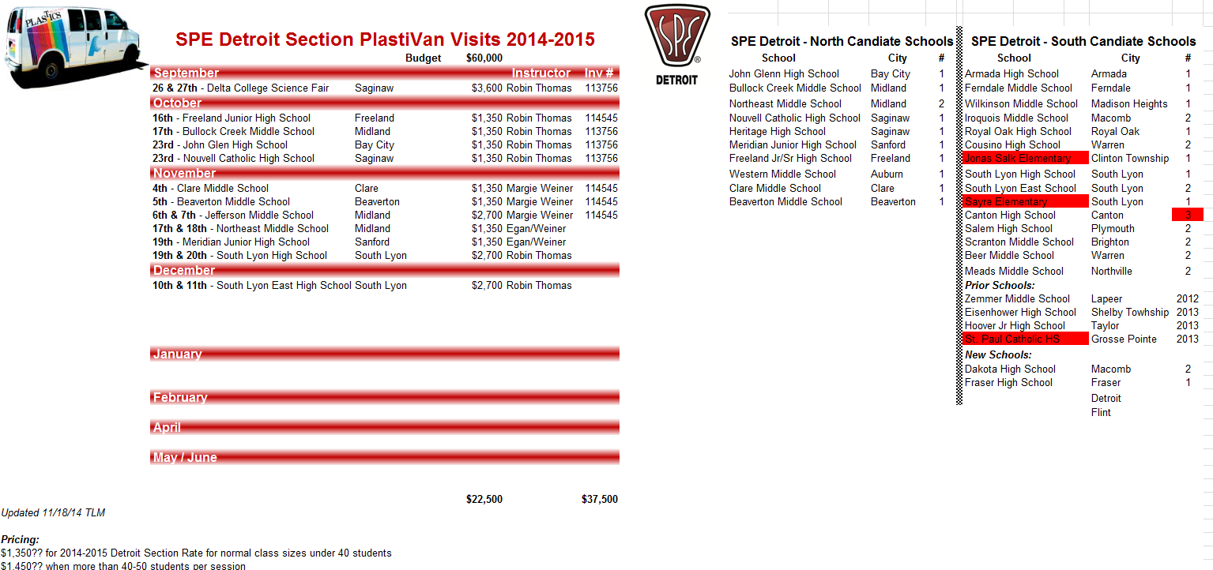
Intersociety Wayne Hertlein
Wayne ran through ESD events calendar. Full report follows:
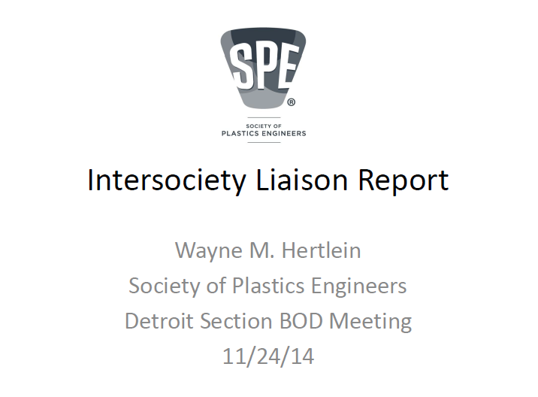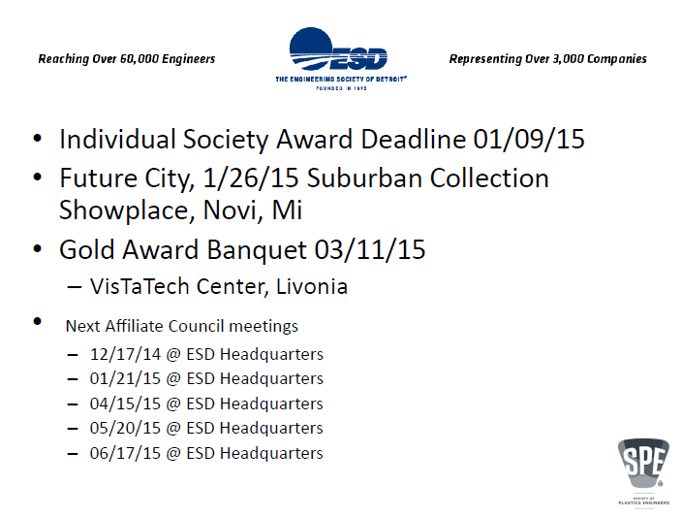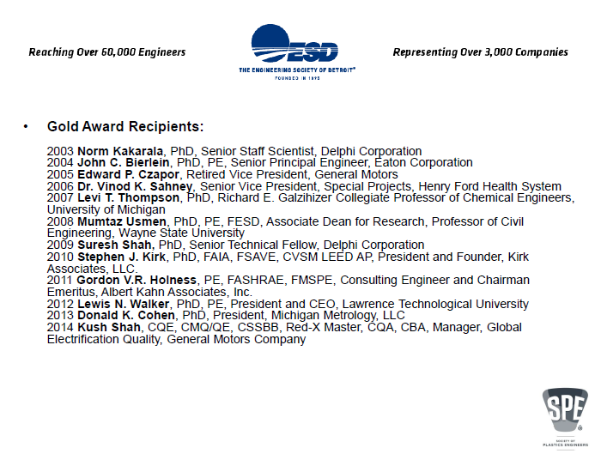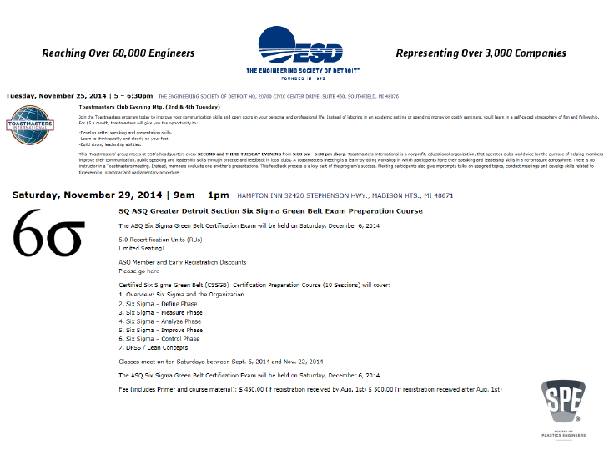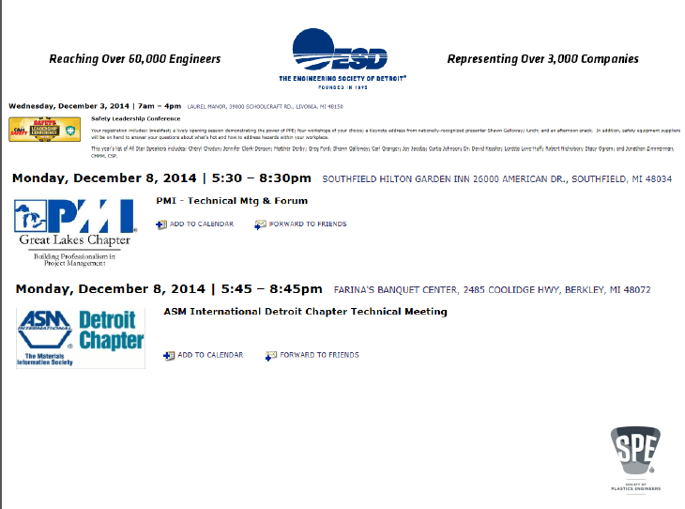

Second Vice President Gary Kogowski
Advertising Chris Surbrook
No Report

Newsletter Gary Kogowski
Articles are due by December 12. Planned distribution date is December 22.

Communication Irv Poston
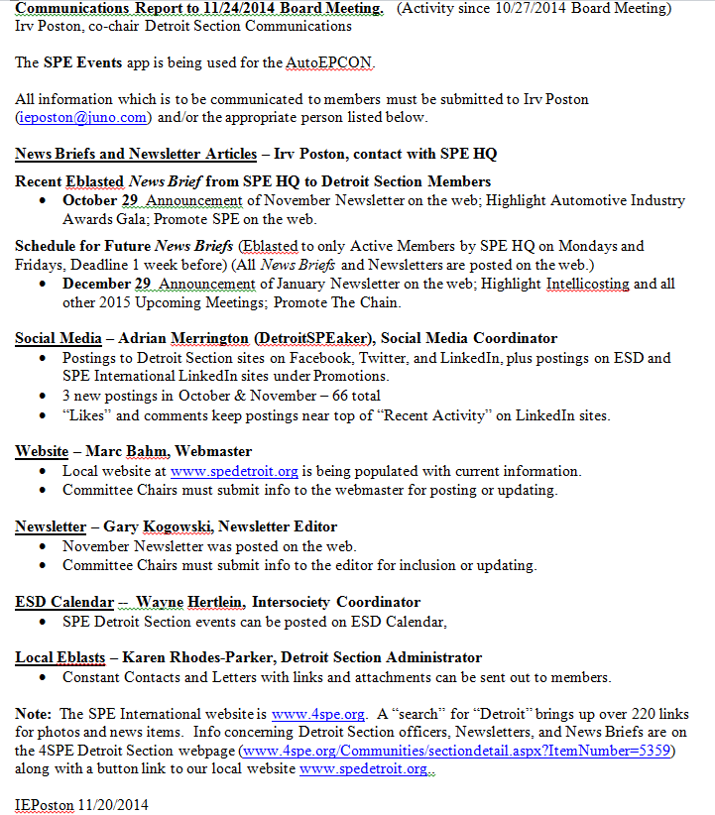

Webmaster Update Marc Bahm
Marc gave a brief update.

Historian T. Powers/W. Hertlein
Wayne showed officer listing that is in process; if anyone has prior 1981 Trends and Topics, Wayne would like to talk to them. Sassan asked that it be put on the web. Coding to scroll through the years in time line fashion is something to be worked out.
Tom Powers it to do a bullet style history for Marc to put on web.

Old/New Business Sassan Tarahomi
Holiday Dinner – December 11 at Redwood Steakhouse and Brewery in Flint.

TPO Founders and Emeritus Member Award was presented to Tom Powers.

Nippani noted that we need nominations for Councilor and present name to SPE International at three months prior to ANTEC March 23-25, 2015. It was agreed that board would nominate Sandra McClelland for a second three year term. A call for nominations is to be in the next newsletter.

Tom Powers suggested putting visitor’s presentations early in the meeting to allow them to leave earlier if desired.

Sassan discussed a board member that is no longer active and the need to correct situation. Norm agreed to take on the responsibility to resolve with that person.

2014 Pinnacle and Communication Award – Sassan provided the following update.
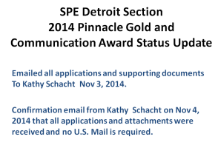

8:30 Meeting Adjourned Sassan Tarahomi
Next meeting - Meeting Day & Date: Monday, February 2, 2015

Meeting Location Remote Location Call-In Information
American Chemistry Council None U.S.: 626-677-3000
1800 Crooks Road Pass Code: 8045975
Troy, MI 48084
Appendix - Agenda
Society of Plastics Engineers Detroit Section
Board of Directors Meeting
Proposed Agenda

Meeting Day & Date: Monday, November 24, 2014

Meeting Location Remote Location Call-In Information
American Chemistry Council None U.S.: 626-677-3000
1800 Crooks Road Pass Code: 8045975
Troy, MI 48084

5:10 President 55 mins. Sassan Tarahomi
5:10 Dinner (15 min.)
5:25 Meeting Call to Order (1 min.) Sassan Tarahomi
5:26 Welcome and Introductions (4 min.) Sassan Tarahomi
5:30 President’s Message (reserved for special item) (10 min.) Sassan Tarahomi
5:40 Approval of Minutes- October 27, 2014 Mtg. (5 min.) Bob Petrach
5:45 Councilor’s Report (5 min.) Sandra McClelland
5:50 Treasurer’s Report (5 min.) Tom Powers
5:55 Technical Conferences
- 2015 TPO Conference Update (5 min.) Bill Windscheif
- 2015 Auto EPCON Update (5 min.) Gary Kogowski

6:05 President Elect 25 mins. Adrian Merrington
6:05 Chapter Liaisons Report (2 min per chapter) (10 min.) Chapter Liaisons
6:15 House & Programs -2014/15 5 min.) Sassan Tarahomi
6:20 Membership (5 min.) Gary Lawrence
6:25 Nominations/Elections (5 min.) Nippani Rao

6:30 First Vice President 45 mins. Wayne Hertlein
6:30 Next Generation Advisor (5 min.) Furkan Akdemir
6:35 Social Events (5 min.) Chris Surbrook
6:40 2015 Material Auction (5 min.) Chris Surbrook
6:45 Education (5 min.) Sandra McClelland
6:50 Education - Scholarships (5 min.) Tom Miller
6:55 Education – Schoolcraft Comm. College (5 min.) Armando Sardanopli
7:00 Education – MMMC & Delta College (5 min.) M. Wendt & T. Miller
7:05 Education – Michigan State University (5 min.) Fred Dean
7:10 Education – Ferris State University (5 min.) M. Wendt & T. Miller
7:15 Education – Kettering University (5 min.) Steve Keinath
7:20 Education - Plastivan & Essay Contest (5 min.) Tom Miller
7:25 Intersociety(5 min.) Wayne Hertlein

7:30 Second Vice President 30 mins. Gary Kogowski
7:30 Advertising (5 min.) Chris Surbrook
7:35 Newsletter (5 min.) Gary Kogowski
7:40 Communication (5 min.) Irv Poston
7:45 Webmaster Update (5 min.) Marc Bahm
7:50 Awards (5 min.) Nippani Rao
7:55 Public Interest (5 min.) Dawn Cooper
8:00 SPE Golf Outing (5 min.) Nippani Rao
8:05 Historian (5 min.) T. Powers/W. Hertlein

8:10 Old/New Business (10min.) Sassan Tarahomi
8:21 Meeting Adjourned (1 min.) Sassan Tarahomi

